Article title - it should be concise and meaningful. Titles are often used in information retrieval systems. Avoid abbreviations and formulas where possible

Name SURNAME*1, Name FAMILY NAME2 …

1 Afiliation, full address, country  
2 Afiliation, full address, country  
2 ….

ABSTRACT  
maximum 250 words.

Keywords: maximum 5

1. Introduction

State the objectives of the work and provide relevant background, avoiding a detailed literature review or summary of results. The structure of the article should include clearly defined and numbered sections. For typical papers presenting research results, it is recommended that the article include: an introduction, a description of the experiment, results and discussion, a summary and a list of references. Subsections should be numbered as in this template (the abstract should not form part of the numbered sections). This numbering should also be applied to internal cross-references: do not refer only to 'text'. Each subsection may have a short heading. Each heading should be on a separate line. Do not use paragraph spacing in section text. Font attributes should be as in this template.

Please ensure that any reference cited in the text is also present in the reference list (and vice versa). Use the generally accepted rules for citing references regarding:

* citation style (references should be numbered in the order in which they appear in the text and indicated by number(s) in square brackets) (*example of bulleted list formatting*)
* internet sources (the full URL and date of access should be given),
* references to preprints (you can refer to preprints that are relevant to your work, but they should be clearly marked as such, for example by including the word “preprint”).

Examples of how to cite references are given at the end of this document.

Abbreviations that are not standard in the field should be defined when they first appear in the article. Ensure consistency of abbreviations throughout the article.

2. Experimental

2.1. Materials

Experimental should include brief details of the methods used such that a competent researcher in the field may be able to repeat the work.

2.2. Methods

Methods that have already been published should be summarized and indicated by reference. Any modifications to existing methods should also be described.

Some elements of this section may include bulleted, numbered or descriptive lists, e.g:

**Reagent1** was p.a. and was purchased from. (*example of descriptive list formatting*)

**Solvent2** was of a purity suitable for the HPLC method.

2.2.1 NMR spectroscopy *(for example)*

3. Results and discussion

The results should be clear and consistent. This section should explore the relevance of the results of the work, not repeat them. Extensive citations and discussions of published literature should be avoided. Nomenclature and units: Chemical nomenclature, abbreviations and symbols must follow IUPAC rules.

3.1. Mathematical formulae

Formulas should be written with Times New Roman 11 pts size, indexes - 7 pts, preferably made with MS Word equation editor - please embed mathematical equations in the text as editable text rather than as images. Number all equations consecutively, which must be displayed separately from the text (if explicitly referred to in the text).

$v=\left(\frac{a^{t}}{u_{1}},\frac{\cos{t}}{10u_{2}}\right)$ (1)

where: v – velocity, *a*, *t*, *u*1, *u*2 – other variables.

All symbols should be annotated.

3.2. Figures, diagrams, etc. ...

Figures, diagrams, photographs, images etc. graphic objects must be embedded in the correct place in the article. Source files may be required at the editing stage of the article.

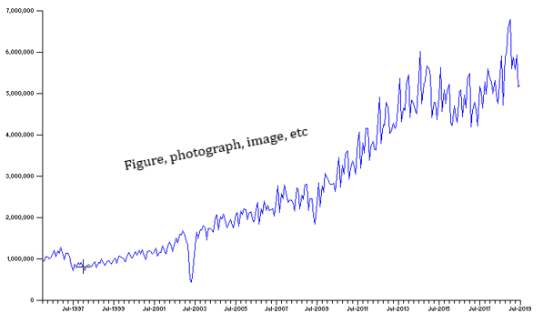

Fig. 1. Schematic representation of.....

Images should be of the highest possible resolution, minimum 1200x1200 pixels. Depending on the type of file, the appropriate file format should be used:

1. for vector graphics, the EMF or EPS format is preferred, (*example of numbered list formatting*)
2. for colour or greyscale photographs or bitmaps use TIFF or JPEG format.

Text in illustrations should be kept to a minimum, but all symbols and abbreviations used should be explained.

3.3. Tables

Tables should be inserted as editable text, not as an image. Tables should be placed after their citation in the text. Tables should be numbered according to their order in the text, and any comments on tables should be placed below their content.

Table 1. Table title....

|  |  |  |  |
| --- | --- | --- | --- |
| **Description 1** | **Description 2** | **Description 3** | **Description 4** |
|  | 3.3210 |  |  |
|  | 4.4444 |  |  |
|  |  |  |  |

3.4. Conclusions

The main conclusions of the results of the work can be presented in a short Conclusions section. This can stand alone or be a subsection of the Results and Discussion section.

Acknowledgements  
List those individuals who provided help during the research. Funding: This work was supported by the National Institutes of Health [grant numbers xxxx, yyyy].

References

[1] Reference to a journal publication: Van der Geer, J., Hanraads, J.A.J., Lupton, R.A., *J. Sci. Commun*., **163**, 51‑59 (2016).

[2] Reference to a book: Strunk Jr., W., White, E.B., The Elements of Style, fourth ed. Longman, New York, 2000.

[3] Reference to a chapter in an edited book: Mettam, G.R., Adams, L.B., How to prepare an electronic version of your article, in: Jones, B.S., Smith , R.Z. (Eds.), Introduction to the Electronic Age. E‑Publishing Inc., New York, 2009, pp. 281–304.

[4] Reference to a website: Cancer Research UK, 1975. Cancer statistics reports for the UK. http://www.cancerresearchuk.org/aboutcancer/statistics/cancerstatsreport/ (accessed 2016/12/30).

[5] Reference to a dataset: Oguro, M., Imahiro, S., Saito, S., Nakashizuka, T., 2015. Mortality data for Japanese oak wilt disease and surrounding forest compositions. Mendeley Data, v1. http://dx.doi.org/10.17632/xwj98nb39r.1.